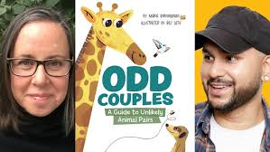

**Odd Couples:**

**A Guide to Unlikely**

**Animal Pairs**

Maria Birmingham

Illustrated by Raz Latif

What Do They Have in Common?

Match the animal pairs from the book to their common characteristics.

| Common Characteristics | Animal 1 | Animal 2 |
| --- | --- | --- |
| They dig dens in the snow. |  |  |
| They use their tails to communicate. |  |  |
| They have pouches. |  |  |
| They are strong swimmers. |  |  |
| They use their stink for protection. |  |  |
| They have fingerprints. |  |  |
| They snuggle up. |  |  |
| They have lots of teeth. |  |  |
| They hum. |  |  |

**Extension:** Can you find another animal that has the same characteristics as the ones above?

E.g. What other animal has a pouch for its young?