
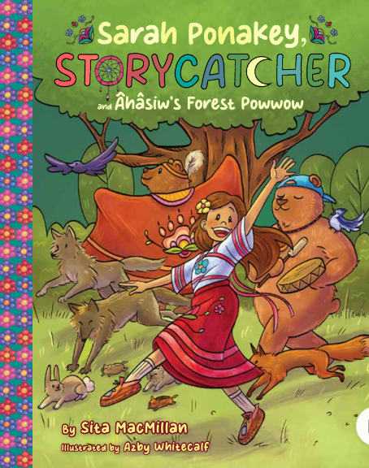
Sarah Ponakey, STORYCATCHER
And Âhâsiw’s Forest Powwow
Sita MacMillan
Illustrated by Azby Whitecalf

Ribbon Skirts & Dancing
On page. 62, Sarah expresses,
“My heart feels full watching all of the rainbows of ribbons touching the ground and swinging into the blue sky.”

Draw a picture to show the colours of the ribbons flowing through the sky.

