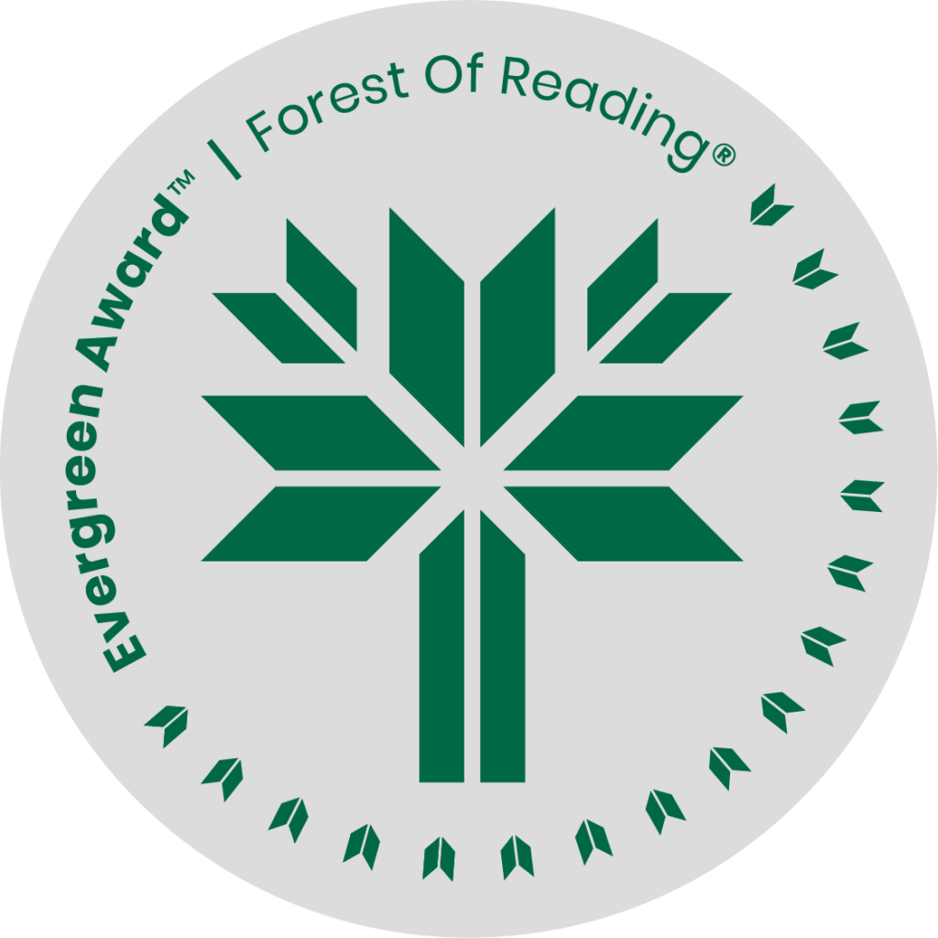

Becoming a Matriarch by Helen Knott

**SHELF TALKER HERE** (Basic elevator pitch - 30 seconds)**:**

*Becoming a Matriarch* is a memoir of grief and survival, a story about healing, and growing up into the person you were meant to be. Her stories of the strong, fierce, loving women in her family are infused with what she calls “intergenerational joy” and love. This is a book for everyone who is looking to understand their place in their family and culture, and for everyone who is grieving the loss of a loved one.

If you liked Becoming a Matriarch you may like:

* Firekeeper by Katlia (Catherine Lafferty)
* Medicine Wheel for the Planet: A Journey Toward Personal and Ecological Healing by Jennifer Grenz
* Mamaskatch by Darrel J. McLeod
* Northern Wildflower by Catherine Lafferty
* Our Voice of Fire: A Memoir of a Warrior Rising by Brandi Morin