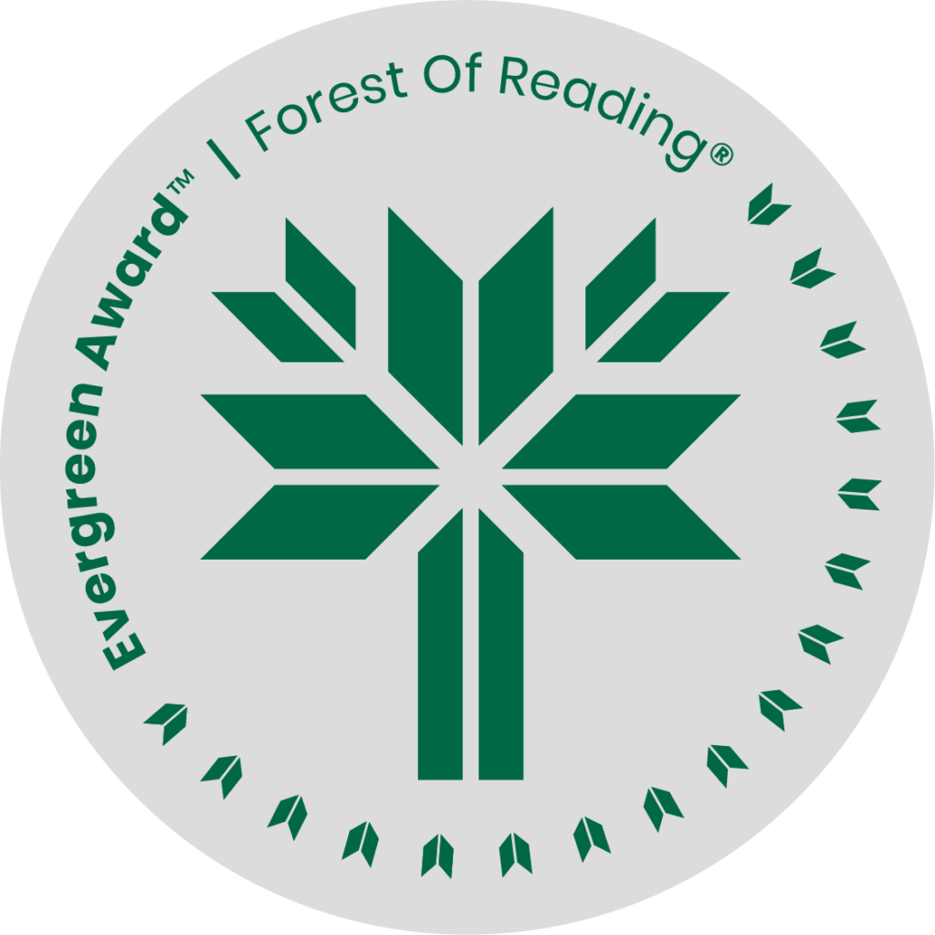

Crooked Teeth: A Queer Syrian Refugee Memoir by Danny Ramadan

**DISCUSSION QUESTIONS HERE** (Ideally 10 questions to guide discussion of the title):

1. What first drew you into this book?

2. If you were asked to describe this memoir in one sentence, what would you say?

Why did you choose to say that?

3. What made you keep reading this memoir, or what made you hesitate to continue reading?

4. Which portion of the memoir grabbed your attention the most? The least?

Why do you think that was the case?

5. Did Ramadan’s memoir bring to light any new or misunderstood ideas about a refugee’s

experiences?

6. Ramadan uses the imagery of crooked teeth regularly and does clarify his use of this

imagery. Did this imagery effectively communicate to the reader the emotions and sentiments

that Ramadan outlines?

7. Ramadan discusses several individuals who were part of his life during certain times. Why do

you think Ramadan may have spoken about these individuals and not others?

8. Ramadan spends some time explaining the private sponsoring process for refugees in

Canada. Do you see any issues that could potentially be addressed to create a safer system for

refugees coming to Canada?

9. Ramadan opens his memoir with the line, “Writing this memoir is a betrayal.” Why do you

think Ramadan views this memoir in this way?

10. Were you satisfied with how Ramadan chose to end his memoir? Why or why not?