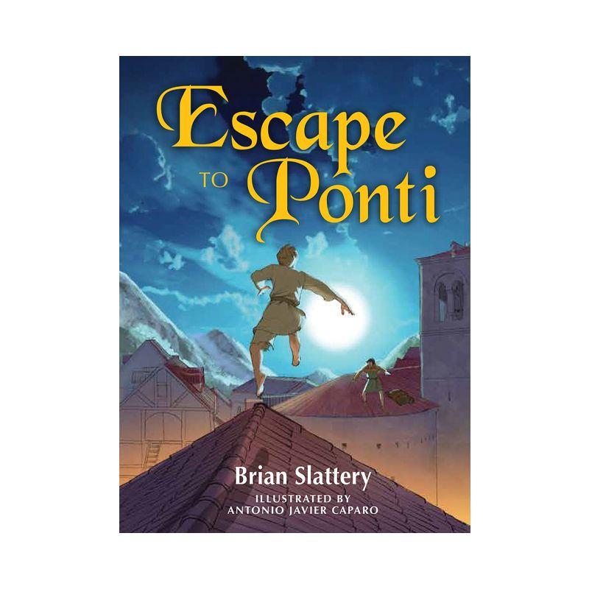

**Discussion Questions**

1. As you grow as a reader, there are fewer books geared to you that include illustrations. How did the illustrations in *Escape to Ponti* impact your reading experience?
2. What are the benefits to Bec and Tien Nu partnering up? What are the challenges?
3. Whys is Bec’s freedom from Malaspina so important to him?
4. Most of the chapters take Bec to a new unexplored setting. Which ones did you find most memorable? How did this regular change impact the pace of the story?
5. Many of the characters resort to violence to deal with their emotions. Are there other problem-solving techniques that they could use in the context of the story or is violence the only realistic option?
6. To create balance in a novel like *Escape to Ponti* an author like Brian Slattery will often use levity (moments of humour) to break up the tension. What are some examples of levity you found in the novel?
7. What makes Cristofo (the Knight) different from most of the other men in the story?
8. Bec frequently refers to expecting ghosts in the novel. Why do you think that this is in his thoughts?
9. In Chapter 51, Malaspina scoffs at Tien Nu and says “Friend! And what is that worth.” Tien Nu does not have time to answer in the novel. What do you think the character would have said if he had the opportunity? How would you answer the question if you were in this situation with one of your friends?
10. What role do fathers (and their absences) play in the story?