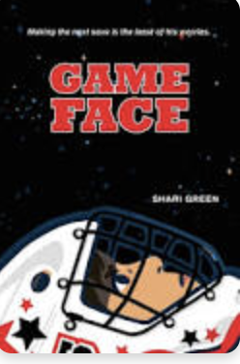 Name: ___________

**Game Face Word Search**

| z | i | n | v | i | s | i | b | l | e | s | d | x |
| --- | --- | --- | --- | --- | --- | --- | --- | --- | --- | --- | --- | --- |
| c | b | f | k | q | h | f | p | v | s | j | a | f |
| o | d | o | c | u | y | l | a | e | e | k | n | g |
| u | h | g | a | o | u | d | n | q | i | c | x | n |
| n | j | y | f | m | u | d | i | k | r | t | i | i |
| s | x | v | m | f | r | r | c | e | r | q | e | k |
| e | m | e | b | a | k | l | a | y | o | m | t | c |
| l | t | b | w | d | z | s | z | g | w | h | y | o |
| o | q | k | t | v | e | o | d | v | e | j | g | m |
| r | w | p | i | h | s | d | n | e | i | r | f | b |
| a | f | z | h | a | p | p | i | n | e | s | s | x |

crease worries panic friendship

counselor courage mocking plummet

anxiety invisible awkwardness happiness