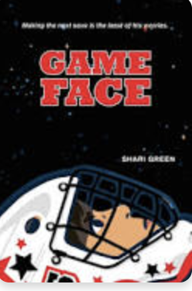 Name: ___________

**Game Face Word Search Answers**

|  | i | n | v | i | s | i | b | l | e | s |  |  |
| --- | --- | --- | --- | --- | --- | --- | --- | --- | --- | --- | --- | --- |
| c |  |  |  |  |  |  | p |  | s |  | a |  |
| o |  |  | c |  |  | l | a | e | e |  | n | g |
| u |  |  |  | o | u |  | n |  | i | c | x | n |
| n |  |  |  | m | u | d | i |  | r |  | i | i |
| s |  |  | m |  | r | r | c | e | r |  | e | k |
| e |  | e |  | a |  |  | a |  | o |  | t | c |
| l | t |  | w |  |  | s |  | g | w |  | y | o |
| o |  | k |  |  | e |  |  |  | e |  |  | m |
| r | w | p | i | h | s | d | n | e | i | r | f |  |
| a |  |  | h | a | p | p | i | n | e | s | s |  |

crease worries panic friendship

counselor courage mocking plummet

anxiety invisible awkwardness happiness