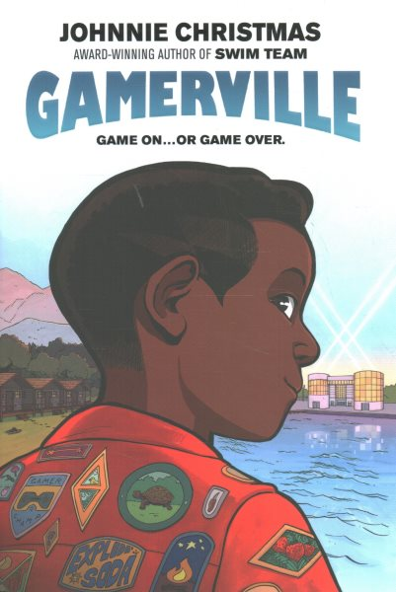Name: ______________________

**Gamerville**

**Create your own graphic novel panel inspired by the**

**events in Gamerville.**