Gorgeous Gruesome Faces

Discussion Questions

*Answer the following questions about Gorgeous Gruesome Faces. Be as detailed as possible. Remember to refer to the book and in some cases personal opinion or experiences.* 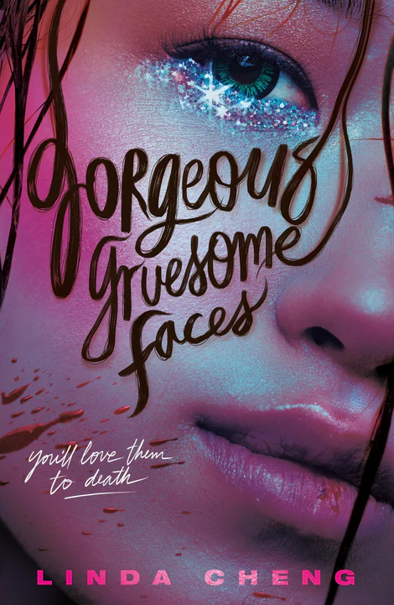

1. Why does Sunny decide to audition for the new reality show? Would you have done the same thing? Why or why not?
2. Why do you think Candie is so adamant about Sunny not staying at the trial camps?
3. Who do you relate to the most: Candie, Sunny or Mina? Explain.
4. Candie is followed by a stalker at one point. What impact does this have on the girls?
5. In the past the girls are on a ‘reality’ show. What impact does this have on their lives? Would you ever go on a reality show? Explain.
6. Describe Candie’s powers. If you could have a similar power what would it be? Why?
7. Social media plays a large role in this novel. What are the benefits and downfalls of social media? What social media do you use? Why?
8. Describe how the relationship between Candie and Sunny changes. Look at the past and present time frames.
9. Sunny says. *“Do you actually want to be doing this? Or is it all for your family? For the celestial maiden?” It’s a question I ask myself sometimes. Is everything I’m working for truly because of my own desires, or my mother’s?”* Is there anything in your life that you can relate to in this statement? Explain.
10. Celebrity plays a large role in this story. Would you ever want to be a celebrity? Why or why not? Does our society place too much emphasis on celebrities? Explain your answer.
11. Photos get leaked in the novel. There is tremendous backlash and online hate. Have you or someone you know ever had to deal with online hate/bullying? Explain.
12. Candie tries to get revenge for the photos. What is your reaction/opinion to what she does?
13. Do you think this was an appropriate ending? How would you have ended the book? Should there be a sequel?