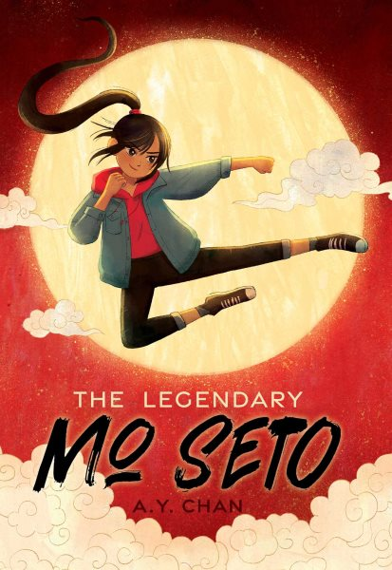 Name: ______________________

**The Legendary Mo Seto**

**Discussion Questions**

1. Mo shares that her name is based on the “cringy virtue” of “modesty” or “humility,” what does your name mean?

2. Why do you think Mo’s mom wants her to stop practicing taekwondo, and try something like flute lessons or ballet?

3. Chapter 5 is titled: “Clearing Clutter Clears the Mind.” Does your family have any similar words of wisdom?

4. Mo’s mother and father do not want her to have her ancestor’s journal; do you agree with Mo’s decision to sneakily make her own copy? Why or why not?

5. Mo goes through quite a transformation in order to audition for the movie; she cuts her hair and fills her shoes with memory foam and Play-Doh, and creates a new persona. What would you do to achieve a dream like Mo’s?

6. Why do you think every time Mo describes one of Cody Kwok’s movies, she calls it her favourite?

7. Nacho wears shirts with different puns on them throughout the story. Which was your favourite? Can you think of a new one that he would enjoy wearing?

8. The moves in the *Book of Joy* are named after small animals, like *As the Chipmunk Charges* and *Earthworm Leaps into Heaven*. What do you picture when you hear the names?

9. Do you agree with the decision Nacho’s Gramps made to pretend to be Mo’s guardian for the audition? Why or why not?

10. Why do you think Mo’s mother didn’t recognize her when Mo was on TV being interviewed with Cody Kwok?

11. What was your reaction when Dax helped Mo save Sanjay after the explosion at the audition?

12. What do you think the title of Chapter 35 means: “The Whole World’s a Stage”?

13. How do you think the story would have turned out differently if Mo’s father had shared their family history before the audition?

14. What do you think will happen next in Mo’s story?