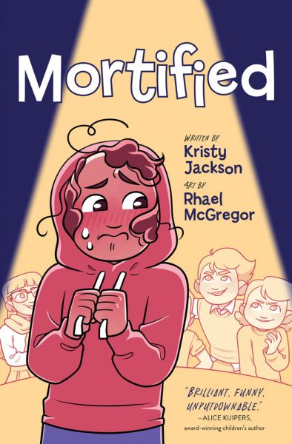

**“Mortified”**

**Word Search**

Can you find the 19 hidden words below?

