Name:______________

Vocabulary Match Up

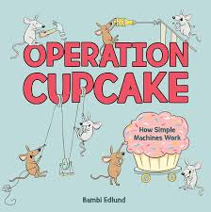

Insert the highlighted words into the chart so that the terms match the definitions. Good luck scientists!

force axle load task pivot resistance

| Term | Definition |
| --- | --- |
|  | A rigid rod or bar connected to the centre of a wheel |
|  | An object being moved |
|  | The effort needed to move an object |
|  | The point on which an object turns |
|  | A force that slows movement |
|  | Some wok to be done |