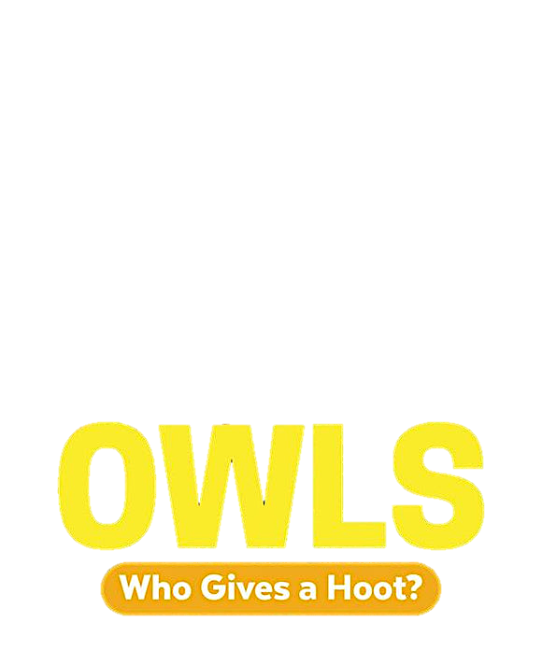

Types of North American Owls Word Search

BARRED

BOREAL

BURROWING

EASTERN SCREECH

ELF

FURRIGINOUS PYGMY

FLAMMULATED

GREAT GRAY

GREAT HORNED

LONG EARRED

NORTHERN HAWK

NORTHERN PYGMY

NORTHERN SAW-WHET

SHORT-EARRED

SNOWY

SPOTTED

WESTERN SCREECH

WHISKERED SCREECH

Types of North American Owls Word Search

Answers

