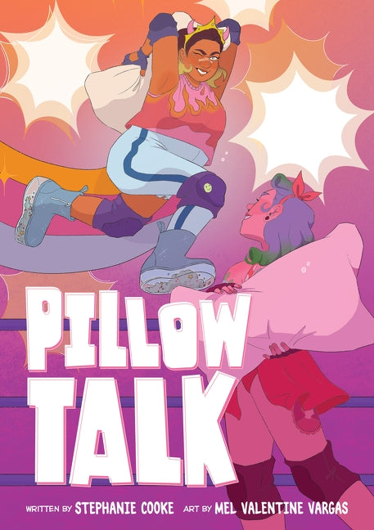

Discussion Questions

1. What were your initial impressions of Grace and Callie’s relationship? Do you have friendships that feel similar?
2. Does Grace and Callie’s university/college experience match what you expect post-secondary school to be like?
3. Why do you think of Grace and her “evil stepmom” have such a strained relationship? Did your perception change as the story progressed?
4. What role does Grace’s body confidence play throughout the graphic novel and how does it evolve over time?
5. What are some of the benefits that Grace experiences while she is a member of the Pillow Fight Federation (PFF)? How does Callie benefit?
6. How does the cost-of-living impact the decisions made by some of the characters? How does this align with your thoughts or experiences?
7. How is feminism at the heart of the PFF?
8. What impact do you think that being bullied as a child had on Grace in the long run?