Name:_______________________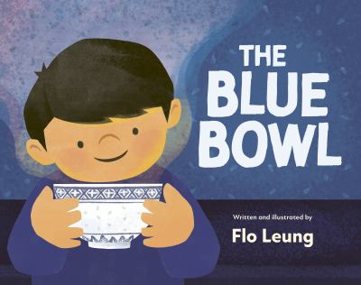

**The Blue Bowl Discussion Questions**

1. Max lists garlic, basil and melting cheese as some of his favourite foods. What are some of your favourite foods?
2. Max wants a cake with vanilla frosting and rainbow sprinkles for his birthday. What kind of dessert would you like to have for your next birthday?
3. Max and his family are Cantonese and eat a lot of traditional foods from Hong Kong. Do you have any special foods that you eat from your culture with your family?
4. Max likes lots of different types of foods and mentions that he eats pizza sometimes at school. What is your favourite thing to have for lunch at school?
5. Max is having his birthday feast at his grandparents house with members of his family. What is something special that you have done (or would like to do) on your birthday?
6. For his birthday, Max doesn’t want to eat traditional Cantonese dishes. What foods does Max want to eat instead?
7. Max’s grandparents brought blue bowls with them when they moved from Hong Kong to a new country. If you had to move to a new place, what is something that you would bring with you?
8. Eating traditional foods from Hong Kong brings Max’s family feelings of comfort and family connection. What is one of your favourite foods that brings you comfort and makes you think of family?
9. Max’s cousins surprise him by mixing their traditional Cantonese recipes with the Italian cuisine he wants for his birthday. What are two foods that you would like to try mixed together?
10. What makes Max’s mango birthday cake so special?