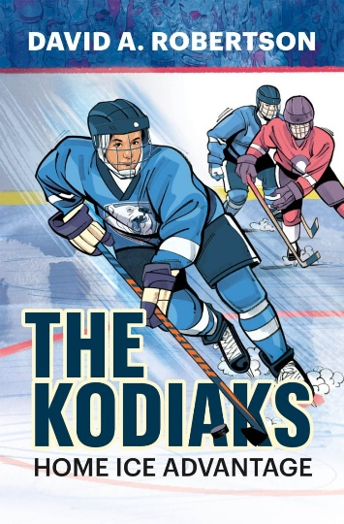

**“The Kodiaks”**

**Word Search Answer Key**

