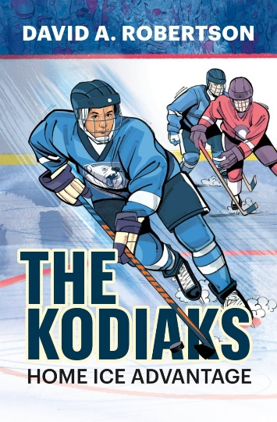

**“The Kodiaks”**

**Word Search**

Can you find the 21 hidden words below?

