****Name: ____________________

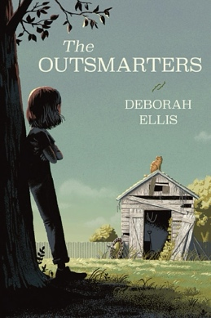

**The Outsmarters by Deborah Ellis**

**Art Activities**

**Visual Art**

1. Krate and her Gran make money selling old treasures in The Junk Yard Shop. Create a found art sculpture or artistic piece. Collect a variety of small objects and create a sculpture or attach them on a shoe box lid. Use this website as a reference or for ideas.

<https://anitasagastegui.com/2020/05/14/1st-grade-found-object-sculpture/>

1. 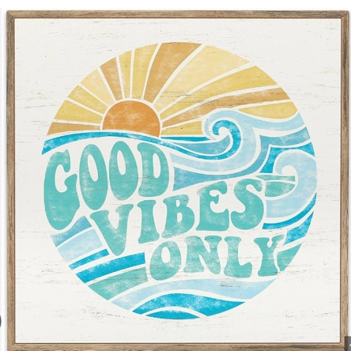Krate uses an anger management book

from the 1970s called, Get Back to Groovy.

Research a little bit about art in the 1970s

and design a cover for Krate’s book.

See the example for colour scheme and font choice.

Picture Source:

https://www.amazon.ca/Open-Road-Brands-Good-Vibes/dp/B0984JRMYM?th=1

**Drama**

Act out your favourite scene from the book or chose one from the list below:

1. Mrs. Cormon refuses to pay Kate for her yard work. Chapter 1, p. 11-12
2. Krate confronts her Grandfather and Gran about her father. Chapter 6, p. 110-111
3. Gran and Krate are in the principal’s office when Ms. Prawn shares her news. Chapter 15, p. 232-234

**Dance**

1. When Krate finds out she passed her GED, she is in the principal’s office and can’t really express her joy. Create a victory dance you think Krate would perform to celebrate her being out of school for good. Search for celebration dances to get an idea of what they might look like.