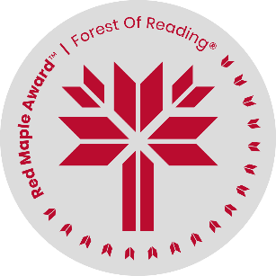 Red Maple Activity: Discussion Questions

*Today I Am: 10 Stories of Belonging  
edited by Jael Richardson*

Name: ______________________________

1. In *The Secret Cousin*, Lonnie reflects on how he feels with the family that he hasn’t known for most of his life (p. 21). Describe Lonnie’s experience with his family members and explain why you think he feels the way he does.
2. Brandon and Wendy in *In A Flash* have moved to a new community, but by the end, Brandon says, “I could make the most of it” (p. 57). What does Brandon learn about accepting a new home?
3. “She’d come to Mulberry a stranger, and she’d never stopped being one” (p. 65). What helps Sal get over being a stranger to the rest of the Mulberries?
4. Discuss the pride Hunter feels in his mother’s response to Mrs. Worthy, and his promise to himself about his feelings about his home (p. 97).
5. On p. 117 we see that Jill’s project “tastes like home”. Describe how she includes Earth and Novus in her new idea of home.
6. In *A Feathered Sakr*, what does Sakr learn about being a protector and being the “man of the house”?
7. “All year, Cassandra’s words had made [Reggie] feel sad and heavy. But now her own words were easing something inside her” (p. 154). What does Reggie learn about how she can use her writing to help herself and others?
8. *The Tomb* is an adventure story but it’s also about a family coming together after a loss. What does Zoya learn about grief and her father’s behaviour?
9. *“What do I do now? Where can I go? Home? What is home now?”* (p. 190). Ziya starts off wondering what home means to her after being freed from the lamp. How does she learn that family means more than your relatives?
10. “*To know myself more every day…to be myself and love myself”* (p. 230). How do you think knowing yourself better (paying attention, like a poet) contributes to being more open to love?