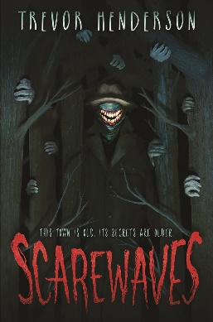Name: _______________________

**Scarewaves**

**Word Search**

