**Little Moons: Discussion Guide**

**About the Book**

**In this moving graphic novel, thirteen-year-old Reanna grieves the loss of her older sister. Can she find comfort through her family’s Ojibwe traditions?**  
It’s been a year since Reanna’s sister, Chelsea, went missing on her way home from school. Without any idea of what happened, Reanna and her family struggle to find closure. Driven from their home by memories, Reanna’s mom moves to the big city. Left behind on the reserve, Reanna and her little brother go to live with their dad. Reanna is hurt and angry that her mom has run away. She feels lonely, abandoned… but she is not alone. Lights turn on in empty rooms, and objects move without being touched.  
**There are little moons everywhere**.



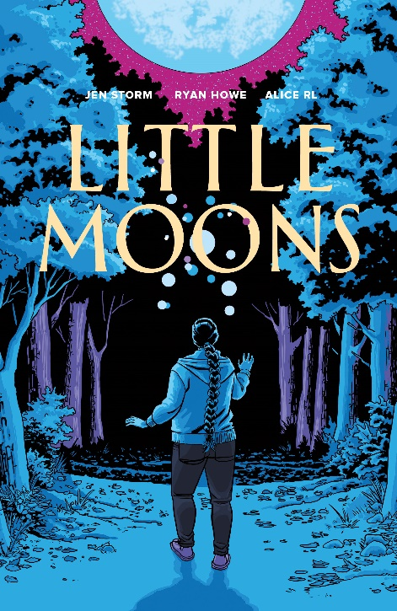

**About the Author**

**Jen Storm** (she/her/hers) is an Ojibwe writer from Couchiching First Nation in Northwestern Ontario. She lives and raises her family, which includes her son, River and stepson Axel, in Winnipeg, Manitoba. Jen completed Deadly Loyalties, her first novel, at age fourteen and has continued writing ever since.

**About the Illustrator**

**Ryan Howe** (he/him/his) is a Canadian cartoonist who fell in love with comics’ unique storytelling language at some point earlier than he can remember, and has been hooked ever since. He’s been collaborating with other comics creators since 2003, providing art for various projects and genres on both the web and in print.

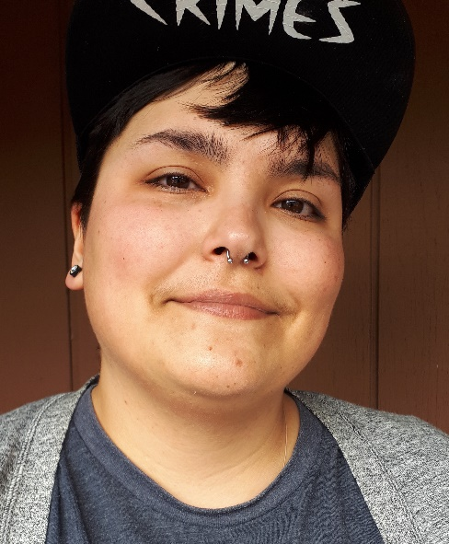

**About the Letterer**

**Nickolej Villiger**(he/him/his) is a comic book artist and illustrator. Nickolej is also a musician and has composed, produced, and arranged for video games and film. Dedicated to his family and fans of his work, he is most fulfilled when creating something that is uniquely his own. Nickolej lives and works in Lethbridge, Alberta.



**About the Colourist**

**Alice RL** (they/them/their) is a professional illustrator and art teacher based in Winnipeg, Manitoba. As a non-binary Ojibwe artist, Alice draws inspiration from their life experiences and cultural teachings. Alice blends these inspirations with a signature palette of bright, playful hues to create stunning juxtapositions of human brutality and emotion with hope and whimsy.



Discussion Questions

1. *Little Moons* opens with scenes of Reanna’s family and regular routine. What are some things you notice about her and her family? Where do they live? What seems important to them?
2. The scenes of Chelsea’s disappearance and the immediate aftermath have very little dialogue. Why do you think the author chose to do this? Would the scenes be more effective with dialogue? Are the scenes effective without it?
3. Everyone in Reanna’s family has their own ways to grieve Chelsea. What do you notice about how each family member tries to process their grief?
4. Comics use a variety of aspects to tell a story – colour is one of them. What do you notice about the colours chosen in *Little Moons*? Why do you think these colours were chosen?
5. Theo sees spirits he refers to as “little moons.” Why do you think only Theo sees these? Have you ever had similar experiences to Theo?
6. There are many traditions included in this book, which author Jen Storm says she learned through her Ojibwe heritage. What traditions have you learned from your own heritage?
7. Have you ever lost a loved one? Did you and your family follow cultural traditions of your own to grieve?

**For more discussion questions and information, see Jerica Fraser’s *Teacher Discussion Guide for Little Moons* in Additional Resources or** [**at this link**](https://www.portageandmainpress.com/Books/T/Teacher-Guide-for-Little-Moons).