
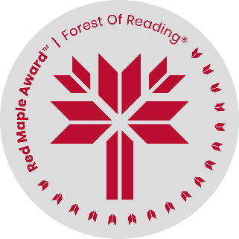
Call Me Al
By Wali Shah & Eric Walters
Creative Writing Activity

Al uses poems to express his feelings. On p.153, his grandfather tells him “Poetry is powerful. When words come from the heart of anyone, they find a place in the heart of another.”
Try writing your own poem to express your feelings (from the heart!) on any topic, using any form of poetry you like. Alternatively, you can write a paragraph or two instead of a poem. Words are powerful; choose them wisely!
____________________________________________________________________________________________
____________________________________________________________________________________________
____________________________________________________________________________________________
____________________________________________________________________________________________
____________________________________________________________________________________________
____________________________________________________________________________________________
____________________________________________________________________________________________
____________________________________________________________________________________________
____________________________________________________________________________________________
____________________________________________________________________________________________
____________________________________________________________________________________________
____________________________________________________________________________________________
____________________________________________________________________________________________
____________________________________________________________________________________________
____________________________________________________________________________________________
____________________________________________________________________________________________
____________________________________________________________________________________________

