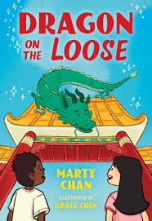

# Dragon on Loose Drawing Activity

# Draw Your Way through the Book

Before Reading:

1. Draw a dragon before you start to read the book. Choose to draw a dragon from your imagination or try this link to help you draw a [dragon.](https://youtu.be/KRAarF177Y4?si=I5AcvbwLHg9_aKKm)



During Reading:

2. Draw Zhu the dragon after reading Chapter 1. Use the description from the text on pages 9 & 10. You can draw Zhu on the roof or flying through the air.



3. Draw Zhu as a puddle and as a tiny dragon.



4. Draw a coyote.



After Reading:

5. Draw Zhu on her way home. Use the description on page 89.

