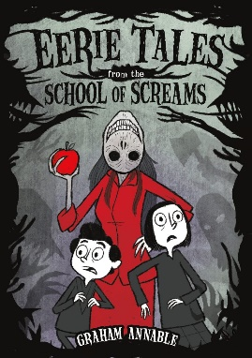Name: _______________________

**Eerie Tales from the School of Screams**

**Discussion Questions**

1. Have you ever had a teacher that liked to tell eerie tales?
2. Each student takes a turn telling an eerie tale. What is your favourite scary story? When did you first hear it, and did it make you scared?
3. What was your favourite tale from the book, and why?
4. Ms. Nomed goes around the room asking the students to tell eerie tales. Davis seems reluctant when called upon. Do you ever feel unprepared or uneasy when your teacher calls on you? If so, how does it make you feel?
5. In “The village that vanished”, two government officials are looking for Wattersburg, but can’t seem to find it. Have you ever travelled outside of your city or town? What was is like to be somewhere unfamiliar?
6. Do you think that the government officials should have trusted the old man in Wattersburg? Were there any signs that things may have been amiss?
7. In “The face in the forest”, Luanne is constantly being asked to do several different things at once. What is your least favourite chore to do? Are there any you don’t mind doing?
8. Luanne keeps helping the head without a body without knowing who they are. What would you do if you came across a bodiless head?
9. In “The ghastly ghost chase”, three kids find a drone. Are there any tech toys that you enjoy playing with?
10. Without knowing the outcome, would you keep chasing the ghost if you were one of the children in “The ghastly ghost chase”?
11. In “The infinite loop of lunacy”, a spacecraft comes across a looping star cloud. Do you agree with the captain’s decision to go through it? Why or why not?
12. Have you ever thought about space travel? What do you think is out there?
13. In “The door to demons”, two children are visiting with their grandfather, Poppi. Do you ever visit with your grandparents? What sort of things do you do together?
14. If you came across what appears to be a portal to another dimension, would you go through it? What do you imagine would be waiting on the other side?