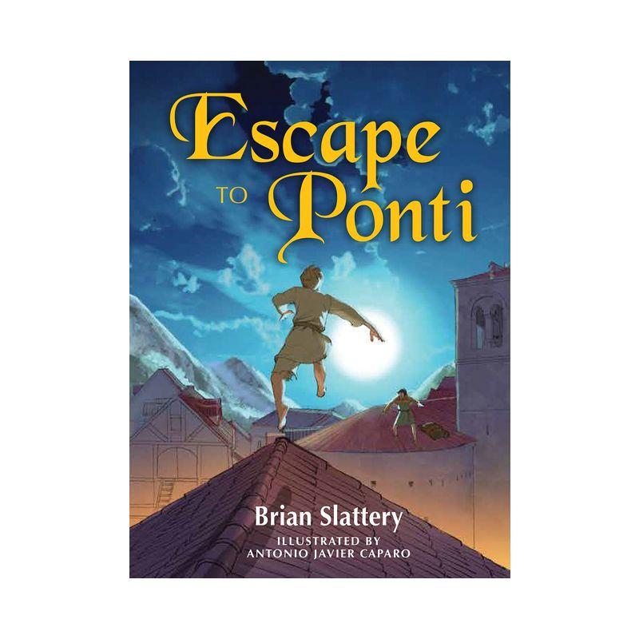

**Predictions**

There are many exciting and fast-paced events that could have turned out very differently in the novel. List some of the key events in the plot that happened, your prediction at the time, and how it turned out.

| **Event** | **My prediction** | **What actually happened** |
| --- | --- | --- |
|  |  |  |
|  |  |  |
|  |  |  |
|  |  |  |
|  |  |  |