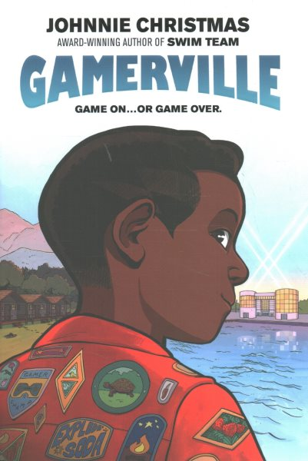Name: ______________________

**Gamerville Discussion Questions**

1. Is there something you love to do as much as Max loves playing video games?

2. Does your school have a video game club? If not, would it be successful at your school, why or why not?

3. Does “Lone Wolf of Calamity Bay” seem like a game you would enjoy playing? Why or why not?

4. Why do you think Max’s parents signed him up for Camp Reset before talking to him about it?

5. If you were in Max’s shoes, would you prefer to go to the video game tournament or the summer camp?

6. What was your reaction when seeing the camp mascot, Major, for the first time?

7. What game or toy would you donate to the Toy Tower if you attended Camp Reset?

8. If you found “Max’s Maximum Methods for Escaping Camp,” would you turn him in or help him escape?

9. What do you think happened to “Pantless Pete, the Wayward Protector”?

10. If you attended Camp Reset, what talent would you perform for the High Summer Ceremony?

11. Have you ever tried a calming exercise, like the breathing Zanzi taught Dylan, and did it work? What do you have in your “toolbox of coping skills”?

12. Max and Zanzi discover that “nothing’s impossible” through their adventures. What is something you have thought was impossible at first?

13. How do you think Max’s time at Camp Reset improved his strategy for Gamerville?

14. What was your reaction to Dylan and Ari’s Guide to Repair?