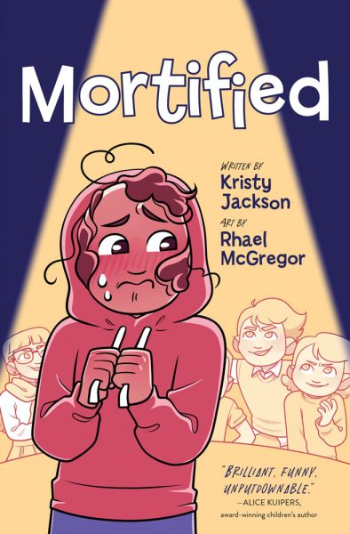

**“Mortified”**

**Vocabulary Match Answer Key**

Match the vocabulary word from “Mortified” to its definition.

regalia a group or gathering of witches

unn erved in a careful or cautious manner

coven relating to a substance with a strong, sweet smell

verenika very enthusiastically or passionately

musky to mortify someone with a look or manner

dollop traditional clothes worn or items carried on special occasions

wither a long speech by a single character in a play

gingerly not being aware of what is happening around you

monologue to make someone feel less confident or somewhat frightened

oblivious dumplings filled with cheese, traditional to Ukraine and Russia

fervently to move around while trying not to be seen

skulked a shapeless mass or blob of something, usually soft food