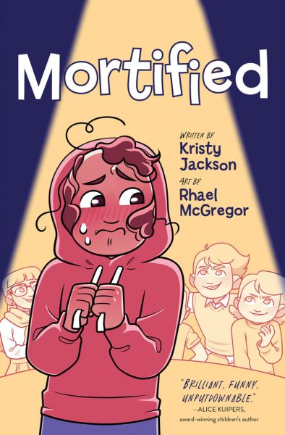

**“Mortified”**

**Vocabulary Match**

Match the vocabulary word from “Mortified” to its definition.

regalia a group or gathering of witches

unnerved in a careful or cautious manner

coven relating to a substance with a strong, sweet smell

verenika very enthusiastically or passionately

musky to mortify someone with a look or manner

dollop traditional clothes worn or items carried on special occasions

wither a long speech by a single character in a play

gingerly not being aware of what is happening around you

monologue to make someone feel less confident or somewhat frightened

oblivious cheese-filled dumplings, traditional to Ukraine and Germany

fervently to move around while trying not to be seen

skulked a shapeless mass or blob of something, usually soft food