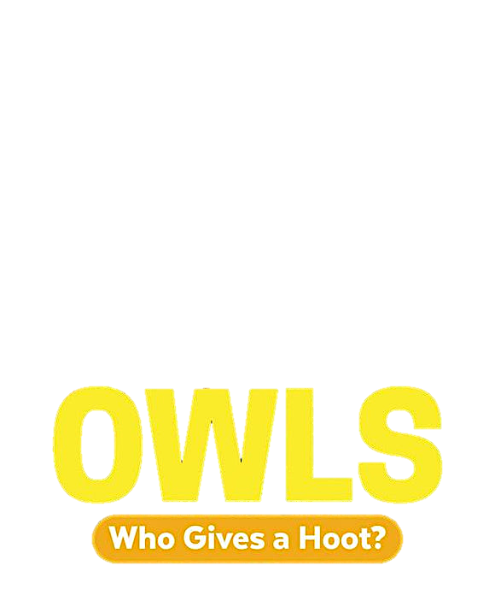

Discussion Questions

1. Do you agree with the author when she suggests that owls are mysterious? Why or why not?
2. What are some key features of owls that are used to identify them?
3. Which owl(s) are you most likely to encounter in your city/town/province? Where might you find them?
4. What are some of the stories or beliefs about owls that stand out to you? Why do you think they stood out?
5. What are some habitat risks that owls could face?
6. If you were to go owling, which tips do you think would be the most helpful from the book?
7. What can be learned from dissecting an owl pellet?
8. How do owls communicate? Did this surprise you?
9. What are some ways that you can support owl conservation?
10. Did anything in the book change your perception of owls as you read through it?