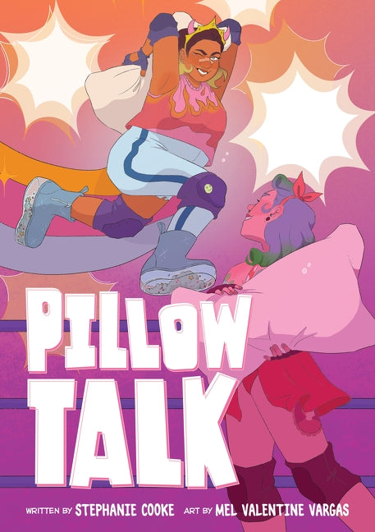

Fightsona Creation

Imagine you are joining the Pillow Fight Federation. Do you think you would rather be a hero or a heel (see pg. 95)? Create your punny name and design a trading card with your costume and some of your key stats.

Check out page 11 of the graphic novel if you need inspiration.