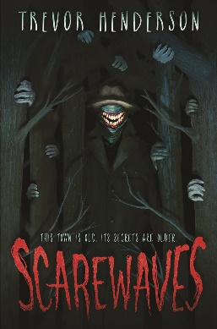Name: _______________________

**Scarewaves**

**Discussion Questions**

1. Which monster in “Scarewaves” did you think was the scariest?
2. Is there anything you are afraid of?
3. Many places have haunted histories, or urban legends. What are some of the legends of the place where you live, if any?
4. The BCON MYSTERY RADIO SHOW details all the supernatural occurrences in Beacon Point. Which story do you find to be the most unlikely to happen?
5. Mary is a new arrival to Beacon Point. Have you ever had to move? If so, how did it feel to be in a new place? If you’ve never had to move, do you think you would like to live somewhere else?
6. Lucas is asked to secure Mr. Sackhead, who makes him feel uneasy. Is there anything in or around your home that gives you the creeps, but you just can’t figure out why?
7. What would you do if you encountered a giant centipede?
8. Have you ever seen someone who you could swear looked exactly like someone you know, a doppelganger? Do you have a doppelganger, that you know of?
9. Jeremy tries his best to make it home before dark. Do you have a curfew? Do you always follow it?
10. Jennifer is Kyle’s regular babysitter. Do you, or did you ever have a regular babysitter. What were they like?
11. On the night of the group’s reconnaissance mission, they order pizza. Do you like pizza? If so, what do you like on it? If not, what type of food would you prefer?
12. The harrowing experiences of the kids from Beacon Point bring the group of kids closer. Do you have a group of friends that you are close with? Who are they? What types of things do you do together?
13. The last chapter of the book is entitled “Back to normal”. Do you think you would be able to go back to normal after an experience like that?
14. Do you think the monsters are gone for good, or will they come back?