Name:_______________________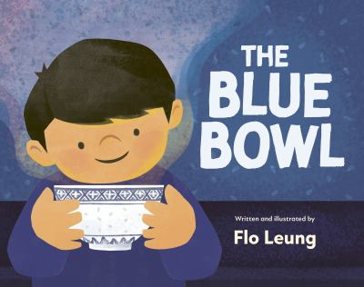

**The Blue Bowl Word Search**

| **T** | **S** | **P** | **A** | **G** | **H** | **E** | **T** | **T** | **I** | **G** | **O** |
| --- | --- | --- | --- | --- | --- | --- | --- | --- | --- | --- | --- |
| **X** | **S** | **S** | **E** | **L** | **K** | **N** | **I** | **R** | **P** | **S** | **N** |
| **C** | **C** | **Y** | **D** | **A** | **A** | **S** | **Y** | **P** | **N** | **C** | **O** |
| **A** | **A** | **W** | **B** | **F** | **Z** | **L** | **B** | **I** | **M** | **Y** | **I** |
| **N** | **L** | **J** | **N** | **O** | **I** | **U** | **S** | **O** | **R** | **A** | **T** |
| **T** | **L** | **H** | **I** | **M** | **W** | **U** | **K** | **Q** | **L** | **D** | **C** |
| **O** | **I** | **E** | **A** | **G** | **O** | **L** | **W** | **R** | **Y** | **H** | **E** |
| **N** | **O** | **F** | **E** | **C** | **N** | **C** | **T** | **A** | **J** | **T** | **N** |
| **E** | **N** | **M** | **A** | **N** | **G** | **O** | **Y** | **F** | **A** | **R** | **N** |
| **S** | **S** | **B** | **V** | **S** | **F** | **E** | **A** | **S** | **T** | **I** | **O** |
| **E** | **A** | **P** | **O** | **N** | **S** | **M** | **A** | **L** | **Q** | **B** | **C** |
| **S** | **K** | **C** | **I** | **T** | **S** | **P** | **O** | **H** | **C** | **O** | **E** |

**Word List**

Cantonese birthday chopsticks

bowl cousins sprinkles

spaghetti mango scallion

feast connection family