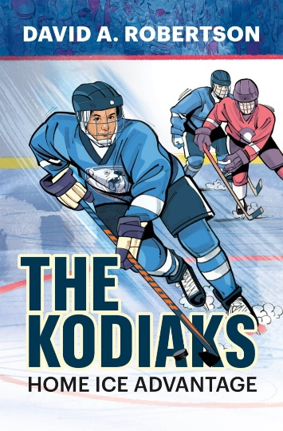

**“The Kodiaks”**

**Writing Prompt**

In the second chapter of the novel, George gives Alex his prized Warrior hockey stick as a going-away present before Alex moves to the big city.

Write about a gift you have either given or received that was of significance to you, and explain why this particular gift was meaningful.