**Asking for a Friend** 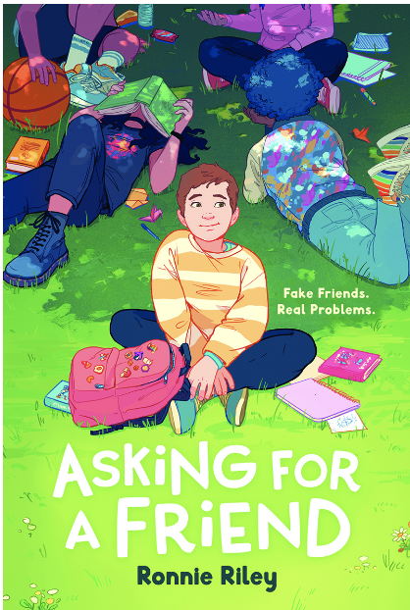

Name: ________________________

**WORDSEARCH ANSWER KEY**

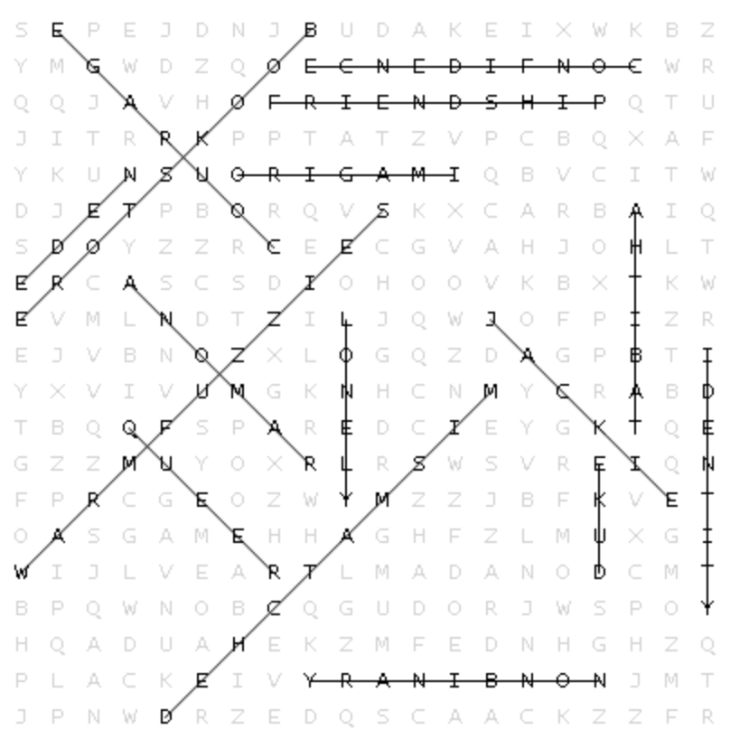

EDEN BOOKSTORE COURAGE FRIENDSHIP LONELY CONFIDENCE NONBINARY WARM FUZZIES

JACKIE MISMATCHED TABITHA RAMONA

DUKE ORIGAMI QUEER IDENTITY