Bertie Stewart is Perfectly Imperfect

Name: ______________________

**WORDSEARCH ANSWER KEY**

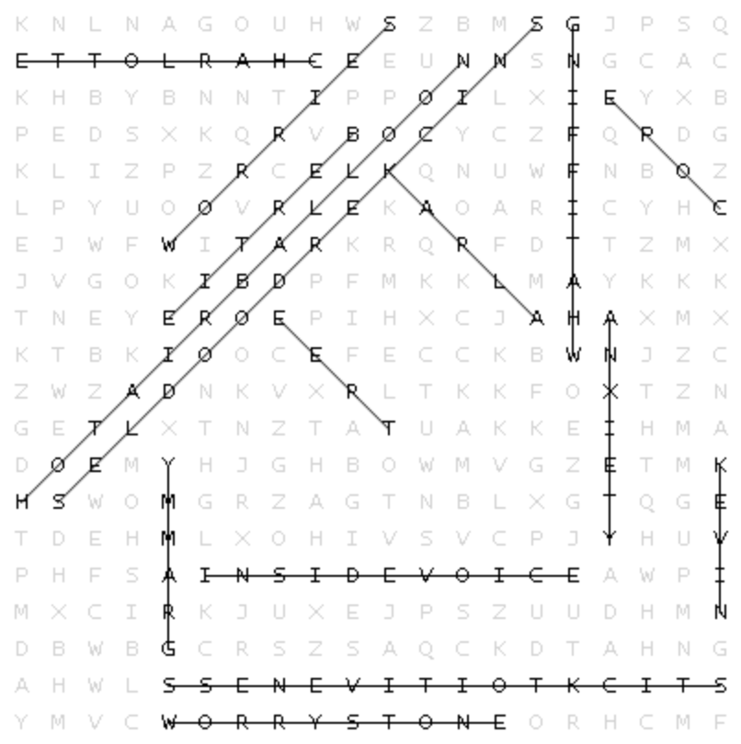

COPE KARLA CHARLOTTE INSIDE VOICE HOT-AIR BALLOON

TREE KEVIN GRAMMY WHAT-IFFING SNICKERDOODLES

ANXIETY BERTIE WORRIES WORRY STONE STICK-TO-ITIVENESS