Bertie Stewart is Perfectly Imperfect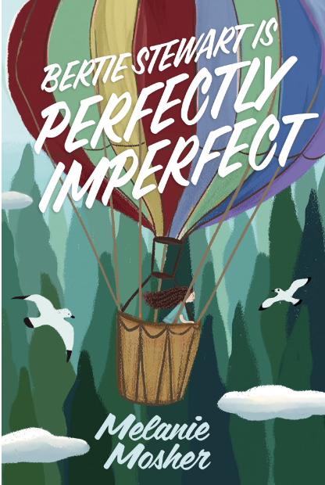

Name: ______________________

**Discussion Questions:**

1. Kevin and Bertie love visiting Bertie’s Grammy who makes many types of delicious treats such as snickerdoodles - those “sugary cinnamon morsels of goodness” with a “cakey texture”. (p.20) How would you describe your favourite comfort food?
2. Grammy states that everyone is perfectly imperfect. How many things can you name that are perfectly imperfect? Do you agree that every person is perfectly imperfect? Why or why not?
3. Bertie and Karla have an argument and as a result, Mr. Dawson tells them they will be partners to present their speeches on stage. Have you ever had to work with someone that you struggled to get along with? Without naming names, explain what this experience was like and how you managed it.
4. Kevin is told, “Don’t be a sissy”, and to “man up” by his father. How do you feel about the way Kevin is treated by his father? How do you think these words affect Kevin?
5. Kevin’s father also describes Kevin as “soft like a girl”. Bertie responds with the statement that “some of the strongest people I know are girls”.(p. 82) Name some of the strong girls and women that you know (or know of). What makes them “strong”?
6. Bertie eventually chooses the career of an aeronaut or hot-air balloon pilot to research for her project. What might draw someone to this career? Do you know about the science behind hot-air ballooning? Do some research to find out more!
7. Grammy’s home is the one place where Bertie’s inside voice is quiet. Where is a calm, safe place for you, where your thoughts are quiet?
8. Grammy also mentions that there are things she does that keep her “hands busy” and her “mind quiet”. What are some of the things she does to distract from her worries? What other things might someone do to keep themselves busy?
9. On page 169, Bertie and Karla are in the hot-air balloon getting to know each other and sharing their thoughts. Karla says, “Guess we all need fixing.” And Bertie replies, “Or maybe we don’t. Maybe we’re good just the way we are…maybe we need to work on being our best self and not compare ourselves to others.” Do you agree or disagree? Is there value in making comparisons, or not?