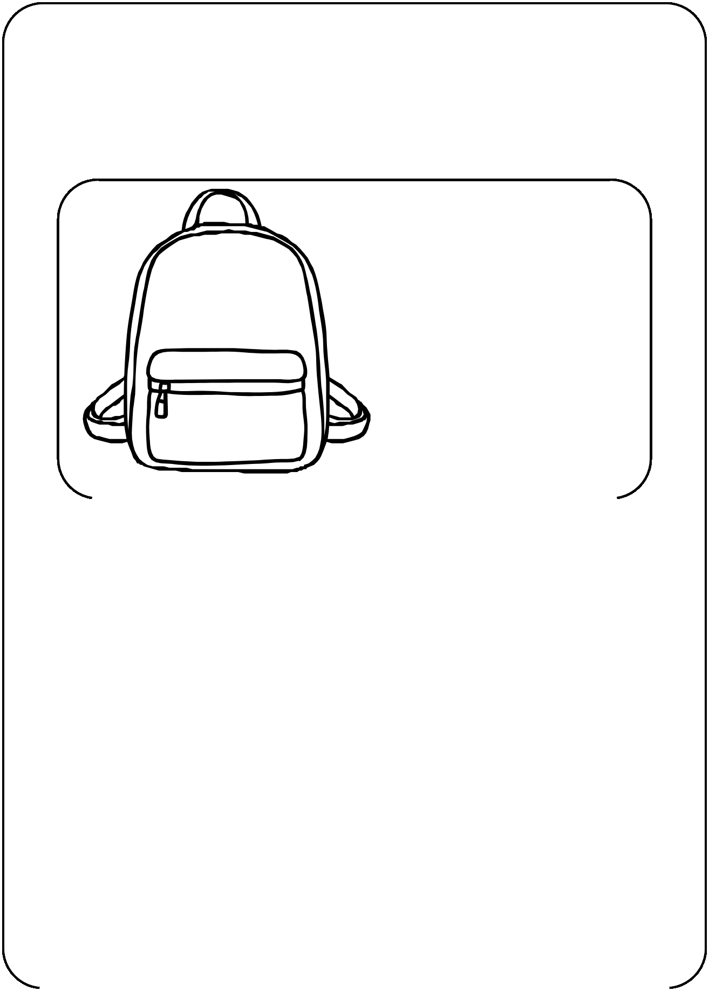
Pack your backpack

When Ali and his family had to leave Afghanistan, he had to pack his most treasured belongings in his backpack. What items would you choose to bring with you if you had to leave your home? Remember that all the items must fit in your backpack. Draw a picture of each item in the box below and then explain why you chose each item.

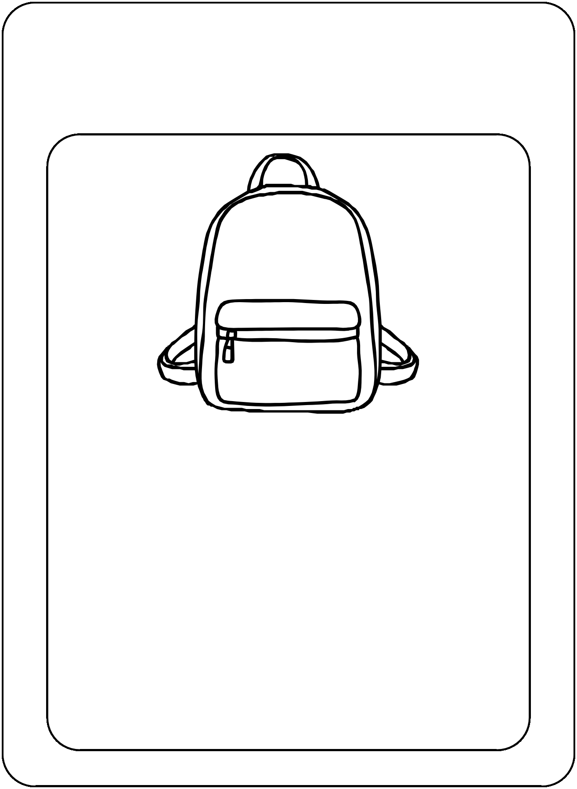
Pack your backpack
When Ali and his family had to leave Afghanistan, he had to pack his most treasured belongings in his backpack. What items would you choose to bring with you if you had to leave your home? Remember that all the items must fit in your backpack. Draw and label a picture of each item in the box below.

