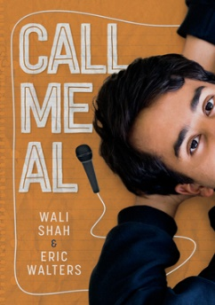
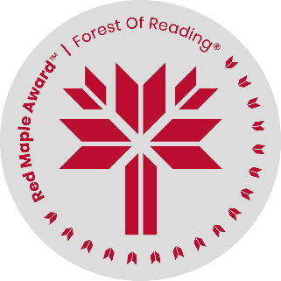
Call Me Al
By Wali Shah & Eric Walters
Discussion Questions

- Before reading, what did you expect this book to be about?
____________________________________________________________________________________________
____________________________________________________________________________________________
____________________________________________________________________________________________
- Do you think the cover is effective? Why or why not?
____________________________________________________________________________________________
____________________________________________________________________________________________
____________________________________________________________________________________________
- Did you enjoy the book? Would you recommend it to a friend? To whom and why?
____________________________________________________________________________________________
____________________________________________________________________________________________
____________________________________________________________________________________________
- What character(s) in the book did you like the most and why?
____________________________________________________________________________________________
____________________________________________________________________________________________
____________________________________________________________________________________________
- Why is Al’s father a taxi driver in Canada instead of a doctor, as he was in Pakistan?
____________________________________________________________________________________________
____________________________________________________________________________________________
____________________________________________________________________________________________
- At the mall, why does Zach tell Al to hide the lunch Al’s mother made before the others get back?
____________________________________________________________________________________________
____________________________________________________________________________________________
____________________________________________________________________________________________
…2
-2-
- Explain what is meant by Al’s grandfather when he says, “You are not white enough to get away with just a call to your parents.” (Page 20)
____________________________________________________________________________________________
____________________________________________________________________________________________
____________________________________________________________________________________________
- What advice would you give to Al when someone calls him “Ali”, when he prefers Al? Do people ever call you by a different name than your preferred name?
____________________________________________________________________________________________
____________________________________________________________________________________________
____________________________________________________________________________________________
- In the back of the book, it says that Wali Shah “faced pressure from his Pakistani-immigrant parents to choose a profession that would justify their many sacrifices.” How do you think his experience helped him in writing Al’s story?
____________________________________________________________________________________________
____________________________________________________________________________________________
____________________________________________________________________________________________
- Have you read other books by Eric Walters? If so, which one(s) and which was your favourite?
____________________________________________________________________________________________
____________________________________________________________________________________________
____________________________________________________________________________________________

