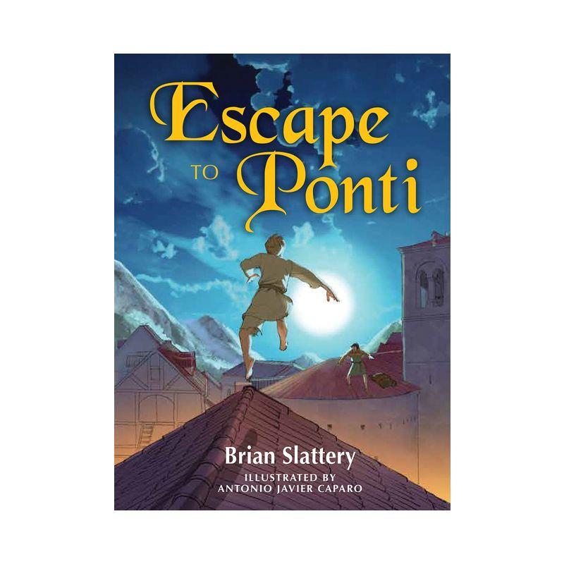

**Added illustrations**

Antonio Javier Caparo brought many of the scenes in *Escape to Ponti* to life through sketch-like illustrations. Choose three additional scenes that you would have liked to have illustrations and create your own sketch to go with each. They can be as detailed or simple as you would like. Make sure to describe the scene that would go with each one.