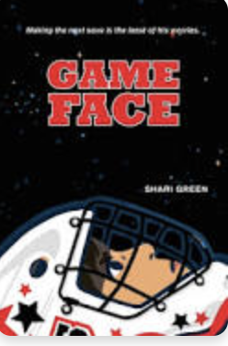 Name: __________

**Game Face - Art Activity**

In **Game Face**, Shari Green gracefully describes how Jonah feels so clearly that readers are able to understand Jonah more. Shari Green’s writing also allows readers to be able to visualize Jonah’s feelings. Below are some examples.

Your task is to create artwork for one or all of the examples that are listed below. You can use paint, pencil crayons, or markers to depict the descriptions. Or, if you would like to create a collage that would be another format to use.

1. On page 27-8, “for the acrobatics going on in my stomach and the what-ifs rattling a doorknob in my brain, threatening to burst in and ruin everything”.
2. On page 51, "The sound burrows into my brain brings numbers back into focus and loosens the band around my chest.”
3. On page 91, “and a cold weight moving through me limbs growing heavy muscle and bone replaced with solid blocks of ice.”
4. On page 97, "It was like a tiny alien creature invaded my brain, took over my controls.”
5. On page 182, “The awkwardness in the room has grown thick enough to smother us.”

If there are other examples of Shari’s writing you would prefer to use to create artwork please use that.

Have fun!