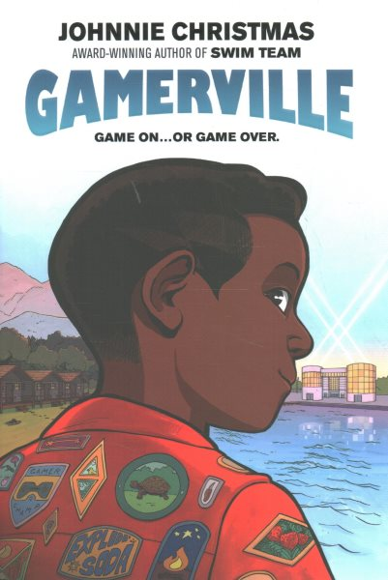Name: ______________________

**Gamerville Crossword**

