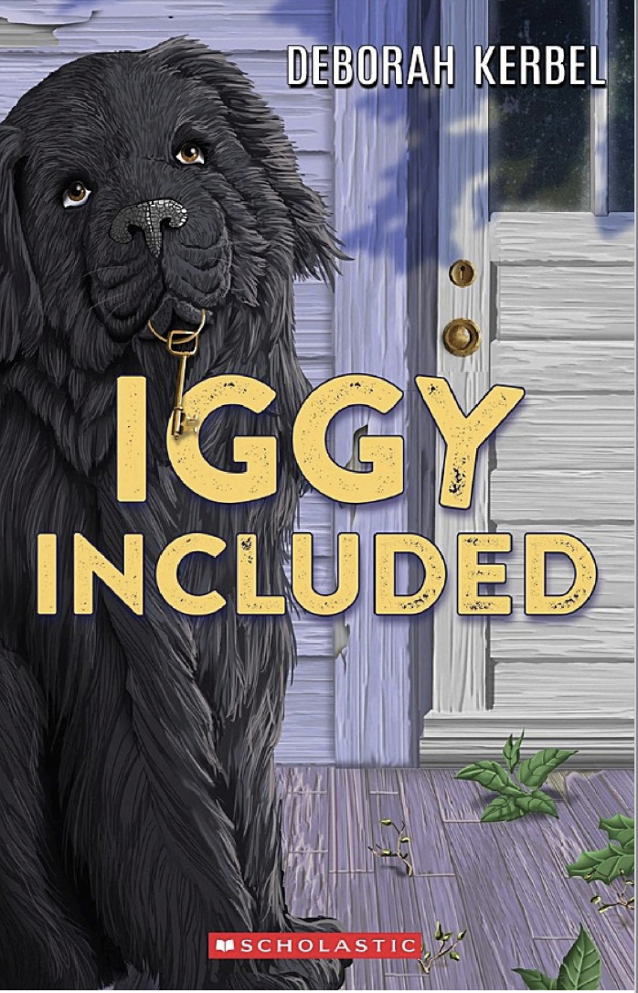

Name: _________________

**Iggy Included Art Activity**

When Paige and her family drove up to the home that they won they could not believe what they saw. The home looked completely different from the pictures online. In the space below, draw what you think the house looks like. Use pencil crayons, paint, markers or any other material you would like.