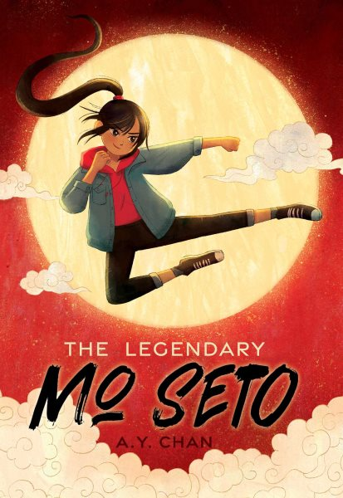 Name: ______________________

**The Legendary Mo Seto**

**Book of Joy Journal Entry**

**Create a move from the Book of Joy and describe the move in a journal entry.**

**________________________________________________________________________________________________________________________________________________________________________________________________________________________________________________________________________________________________________________________________________________________________________**