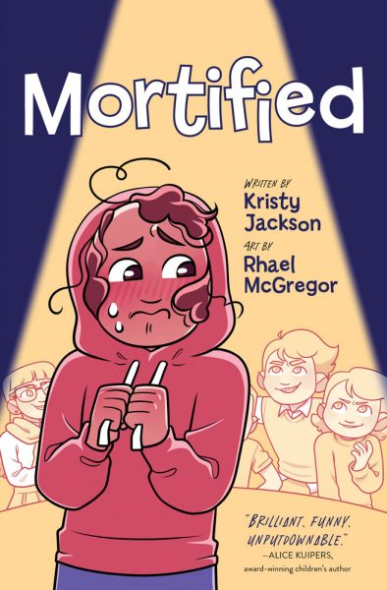

**“Mortified”**

**Writing Prompt**

In “Mortified”, Belinda encounters a series of embarrassing moments she believes are due to a curse. Have you ever experienced any moment similarly mortifying? Write a diary entry journalling what happened and how you handled it.

If you’ve been spared moments as embarrassing as those Belinda has had, imagine a scenario that would leave you “mortified” and explain how you would overcome it!