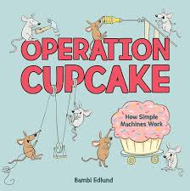

# Science Lab Report

## Scientist’s Name:

## ____________________

Choose one of the experiments from the book and record your findings below.

| Question: |
| --- |

| Hypothesis: |
| --- |

| Materials: |
| --- |

| Procedure: |
| --- |

| Observations: |
| --- |

| Conclusions: |
| --- |