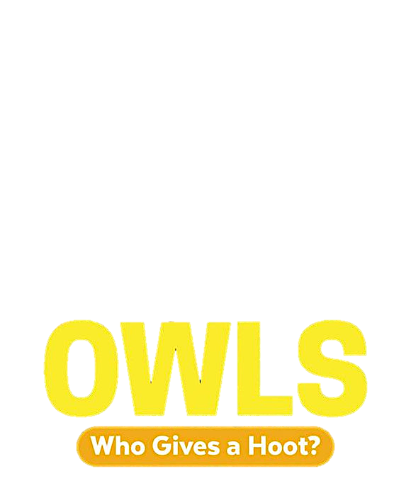

KWL Chart

A KWL chart is one way to organize your learning. Fill out the chart to reflect your reading experience.

|  |  |  |
| --- | --- | --- |
| **K**  What do you already **know** about owls? | **W**  What do you **want** to learn about owls? | **L**  What did you **learn** about owls after reading? |
|  |  |  |