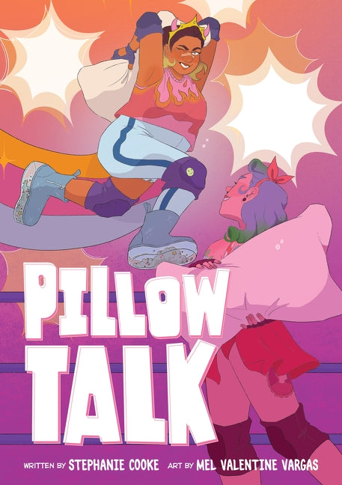

Venn Diagram

There are a few instances in the graphic novel where the Pillow Fight Federation is compared to roller derby. Do some research to find out how accurate that comparison in. Record your findings in the Venn diagram below.

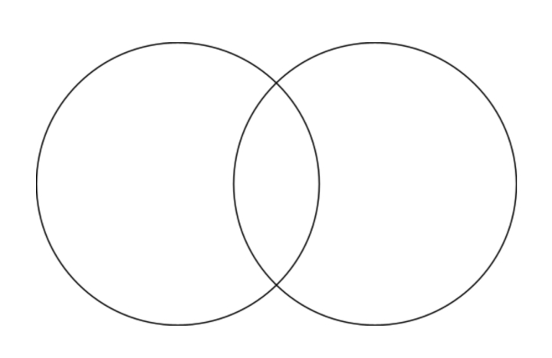

**Pillow Fighting**

**Roller Derby**

**Both**