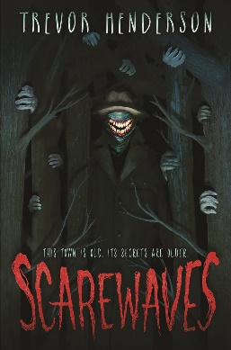Name: _______________________

**Scarewaves**

**Drawing Activity**

In Episode 35 “Weird Deer, Pt. 2” of the BCON RADIO MYSTERY SHOW, hosted by Alan Graves, Nathaniel Raymere encounters a creature with the following description: “The creature’s face was pale and twisted, completely without fur. Nathaniel claimed that the attacking animal had the grinning, horrible features of a human being.” In the space below, draw what you think that would look like.