******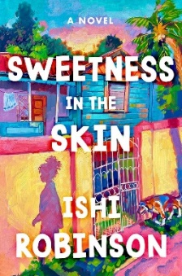***Sweetness in the Skin***

Cookbook Cover Activity

Name: ______________________________ Date: ______________________

Pumkin is making a cookbook with recipes she makes in the book. You have been asked to create the cover! Use the space below for your design. Which baked good(s) from the book would you feature? Would you include a picture of Pumkin and/or a kitchen? Be creative!