Name:_______________________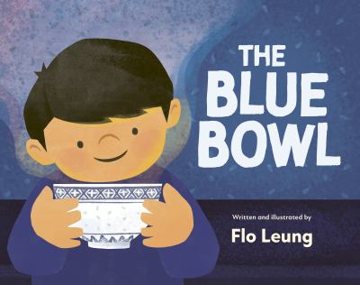

**The Blue Bowl- Suitcase Packing Art Activity**

Max’s grandparents bring their blue bowls with them when they move from Hong Kong to a new country. Using the space below, draw some of the items that you would pack with you in your suitcase that are special to you or your family.

|  |
| --- |